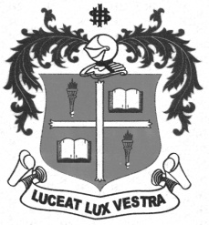
LOYOLA COLLEGE (AUTONOMOUS), CHENNAI – 600 034
B.A. DEGREE EXAMINATION – ENGLISH LITERATURE
FIFTH SEMESTER – APRIL 2012

EL 5401 - INDIAN FOLKLORE

Date : 27-04-2012 Dept. No. Max. : 100 Marks
Time : 1:00 - 4:00

I.Write short notes on any FIVE of the following oral genres: (5x4=20)

- Lullaby
- Villupattu
- Silambaatam
- Folk Dance
- Devaraatam
- Kavadi Aatam
- Folktale
- Bommaalaatam

II.Answer in paragraphs any FOUR of the following in not less than 150 words each: (4x10=40)

- Mention some of our South Indian musical instruments and their features.
- Poikkal kudiraiaattam,Oyilaattam,Bommalaattam are part and parcel of our culture.Explain.
- Mention some of the folk songs used in tamil films?
- Bring out the speciality of the Veena and the Nadaswaram.
- What are traditional folk forms of our culture? Explain at least four of them.

III. Attempt essays on any Two of the following in 300-500 words each: (2x20=40)

- Discuss some of the temple festivals in Tamilnadu incorporated in folksongs and folkdances.
- Write a folk tale from your memory and explain its theme.
- Folk songs which are most common in Tamil Literature.
**********

